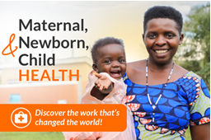

MATERNAL, NEWBORN, & CHILD HEALTH (MNCH) MEETING OUTLINE
Meeting Goal: Educate the office on the importance of MNCH and how World Vision implements this work. Share why MNCH matters to you as constituents. The Member shows support for MNCH by cosponsoring the bipartisan legislative ask or supporting MNCH appropriations. | Long-Term Goal: The Member displays increasing leadership to support U.S. humanitarian assistance. The office knows World Vision and feels supported and accountable to make decisions that honor God and reduce global poverty.

» PRE-MEETING:
- Check out your Member’s Backgrounder:
- Be sure to note the number of World Vision child sponsors in the district/state.
- Spend some time learning more about their priorities, background, and goals. Take note if they’re already supportive of MNCH!
- Read the MNCH brief, the SECURE Health Act one-pager (for House), and the FY27 Appropriations one-pager (for Senate).
- Watch this pre-recorded sample meeting to see other Advocates in a mock Congressional meeting on MNCH.
- Read this Tips Sheet for more helpful information on how to make a meeting feel personal & conversational.
- Check out the Hub for additional MNCH meeting resources.
MEETING TALKING POINTS/AGENDA
» INTRODUCTIONS (6 MINUTES):
INTRODUCTIONS:
- Thank the office for meeting with you. Confirm how much time the staffer has for you.
- Have one Advocate share that those gathered (if you have a group) are constituents and World Vision supporters who advocate for America’s role in the world through humanitarian assistance.
  - Also mention the number of child sponsors in the district/state here to express further support for World Vision.

CONNECT WITH THE STAFFER PERSONALLY:
- If you’ve met with this staffer before, briefly follow up on things you’ve learned about them previously to show that you are working to build a meaningful relationship with them.
- If you have not met with this staffer before, spend a few minutes connecting with them by asking some questions. You might ask: How long have you been serving in the office? What issues are you most passionate about?

TOPLINE MESSAGE:
We are here today, as your constituents, to talk about why we care for mothers and babies around the world and the role the U.S. has played in saving their lives. We would specifically ask for Sen./Rep. ___ to support maternal, newborn, and child health, or MNCH, by:
HOUSE: Cosponsoring the SECURE Health Act, which we will discuss in this meeting.
SENATE: Supporting FY27 appropriations for the Maternal and Child Health account and the Nutrition account

Ask: Before we continue, how familiar are you with World Vision? (Feel free to share the next section even if they are very familiar – it is a good refresher & update)
ABOUT WORLD VISION:
- World Vision is one of the largest Christian humanitarian & relief development organizations that works in nearly 100 countries with over 90% of our staff local to the communities in which they serve.
  - In 2025, World Vision reached 35.6 million people through our 104 emergency responses in 70 countries
  - 1 U.S. Programs example chosen by region (*Your GO will help you choose)
- World Vision’s primary focus is on long-term community development, building resilience so that communities can develop, thrive, and provide for themselves, eliminating the need for long-term aid.
» DIALOGUE (3 MINUTES):
As we begin discussing maternal, newborn, and child health….
IF THE OFFICE SUPPORTS MNCH:
- We’d like to thank you for the ways that Rep./Sen. ___ has supported MNCH by (review the Member’s Backgrounder and list a few).
  - Allow the office to give a brief response, if they have any
IF YOU’RE UNSURE IF THE OFFICE SUPPORTS MNCH/IF THEY DO NOT:
- We’d like to learn a bit more from you first. What are some of the Member’s priorities or interest areas in foreign policy? Are there any specifically related to global health or U.S. humanitarian assistance?
» WHAT IS MNCH? (8 MINUTES):
With that in mind, we’d like to spend just a few minutes talking about MNCH: where we’ve made tremendous progress, where the need remains, and some of the basic interventions that are saving lives.
The U.S has played a major role through significant funding investments - maternal mortality has fallen dramatically, and deaths among children under five have been cut by more than half.
Those gains tell us something important: we know what works. But the work is far from finished.
OPTION 1: You can have someone share their screen to show the photos (below) that correspond with Gloria’s story. We are hoping to engage the staffer with visuals and by “putting a face” to MNCH.
OPTION 2: (If you are not comfortable sharing your screen) Because you have shared the video of Felix’s clinic before this meeting, spend two minutes sharing: “I hope you’re able to watch the video I sent you before this meeting that shows a clinic in Malawi without running water. I was so moved by this video because…”

GLORIA’S STORY SLIDES

[SLIDE 1]
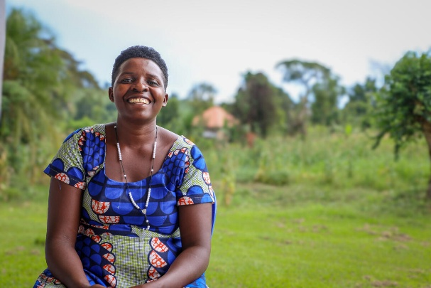
This is a picture of Gloria, who gave birth on the floor of a rural health center in Uganda. With no running water, she cleaned herself with water collected from the nearest source — a swamp. The health center staff were unable to clean their gloved hands between patients, and Gloria quickly developed an infection, a sadly common experience for women in her community.

THE NEED:
- Approximately 287,000 women still die every year from causes related to pregnancy and childbirth. In 2023, that meant about one woman every two minutes.
- Millions of children continue to die before their fifth birthday, largely from preventable or treatable causes. Malnutrition underlies almost half of all child deaths, and even if they survive, they could face lifelong challenges of poor health, limited education, and lower income.
- Despite this need, access to critical maternal care and adequately equipped health facilities—with clean water, trained nurses, and essential medical supplies—remains a significant challenge.
For World Vision, the question isn’t whether we know how to save these lives. We do. The question is whether we will continue investing in the proven solutions that have brought us this far — or risk losing progress that took decades to achieve.

THE RESPONSE:
- The good news is that many of the interventions that protect mothers and children are simple and remarkably practical.
- MNCH programs focus on three fundamental outcomes:
  - Mothers and children are well nourished;
  - They are protected from infection and disease, and;
  - They have access to essential health services.
- In practice, that means:
  - Ensuring a mother can receive prenatal care, deliver her baby with the help of a trained birth attendant, and receive support after her baby is born;
  - Preventing malnutrition, immunizing children, and treating illnesses such as malaria, pneumonia, and diarrhea, and;
  - Making all of this available to every mother and child, no matter where they live.
- We can rely on the expertise of organizations like World Vision to reach out to the most vulnerable. In fact, over the last 15 years, 88% of the severely malnourished children World Vision has treated are fully recovered.
- We also know from experience what frontline health workers make possible. They are often neighbors and trusted members of the community, acting as the first and only point of contact for families who live in remote communities.
Faith and Community Initiative (FCI)
- In fact, recently World Vision was recently chosen by the State Department to lead a consortium of partners in the Faith and Community Initiative, or FCI.
- Through this grant, 30,000 healthcare workers will be trained, and countries will be empowered to tackle their own pressing health challenges.
- This major global health effort is projected to reach 22 million people annually in 16 African countries as well as the Philippines.
- This is an excellent example of World Vision’s MNCH work because the initiative will bring integrated, lifesaving care to more people by strengthening HIV, maternal, and child health services, and addressing critical needs such as nutrition, malaria, and tuberculosis at the community level.
Overall, we believe there should not be a single child dying from what we already know how to treat. And we know this approach works because we have seen the results.

[SLIDES 2 & 3]
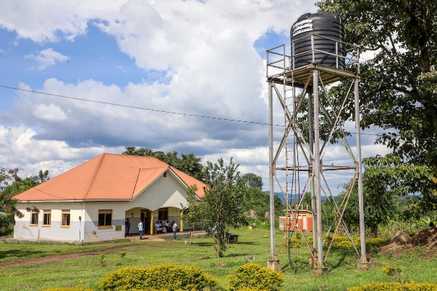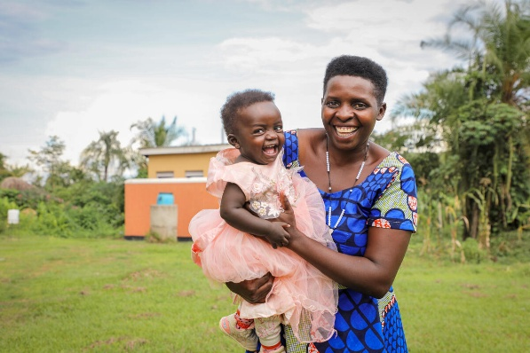
A few years after her first experience, Gloria returned to the same facility to deliver her fifth child, expecting the same hardship. Instead, she found a health center transformed [SLIDE 2]: clean, refurbished, and equipped with running water and handwashing stations. That day, Gloria welcomed another daughter, Stella [SLIDE 3], whose name means “do not worry.” With support from World Vision, the clinic that had once been a place of fear became a place of dignity and care for all the mothers in Gloria’s community.
THE IMPACT:
- The U.S. has been a key player in improving lives like Gloria’s. Our country’s leadership has helped drive a 60% reduction in child mortality and a 38% reduction in maternal mortality in the last 30 years.
- Those aren’t simply encouraging statistics. They are evidence that sustained, targeted commitment produces measurable results.
- The return extends beyond the individual lives saved. Healthy children are more likely to grow, learn, and thrive as adults. Mothers who survive pregnancy and childbirth remain at the center of their families and communities.
- All of this matters to the United States. Disease outbreaks, fragile health systems, regional instability, and disrupted supply chains may not remain confined within national borders.
- Investing early in prevention, trained health workers, nutrition, immunization, and functioning local health systems can help avoid much more costly crises later on.
This isn’t a choice between compassion and fiscal responsibility. Done well, global health programs accomplish both. The opportunity ahead is to protect the progress we’ve made, build on it, and make sure American taxpayer dollars continue producing lasting results.

PAUSE FOR UNDERSTANDING: Before moving ahead, the Cohort Member will decide to pause here, based on the staffer’s engagement, and see if they are following/have any questions.

» U.S. HEALTH AGREEMENTS (3 MINUTES):
The question now is how we protect that progress, and one way to do that is by including MNCH in recent U.S. health agreements.
Prioritization and Funding
- The America First Global Health Strategy is a new foreign policy framework that pivots international health assistance to directly serve American national security, economic interests, and self-reliance goals. However, investments in core maternal & child health and critical nutrition programs were not included.
- This strategy is being implemented through bilateral agreements, or Memoranda of Understanding (MOUs), by the Global Health, Security, and Diplomacy bureau at the State Department. So far, 34 MOUs have been signed.
- Unfortunately, this process has not been transparent, and only a handful of MOUs have been made public. The ones World Vision has seen do not include MNCH, and only 3 MOUs include nutrition.
We mention this because we are hopeful that these types of programs are prioritized in the MOUs, and that Congress continues to appropriate funding for them going forward.
Oversight and Accountability
- As these MOUs are finalized and implemented, we also want to prevent any gaps in access to essential health services, including lifesaving care.
- World Vision believes that the current oversight plan, which is to have one person in the foreign assistance regional hubs overseeing a region of multiple countries, is inadequate.
We are happy to connect you with World Vision’s staff to discuss these agreements further. Reaching mothers & their children with the care they need is important to us, so we look forward to working with Congress, as well as the Administration, to strengthen oversight and accountability measures and ensure that the funding in these agreements is spent as intended.
*FOR HOUSE ONLY: » SECURE HEALTH ACT (3 MINUTES):
As these changes in U.S. global health assistance move forward, Congress has an important opportunity to help preserve lifesaving maternal and child health interventions as part of that work.
One very practical way to do that is through the SECURE Health Act, which focuses on frontline health workers who are essential to stopping disease outbreaks and keeping communities healthy. This bill will make U.S. investments into this workforce, such as the FCI grant we mentioned earlier, more effective, sustainable, and transparent, while promoting the responsible use of taxpayer dollars.
SECURE Health Act (H.R. 8011):
- The SECURE Health Act was introduced by Rep. Jen Kiggans (R-VA) and Rep. Ami Bera (D-CA) in March 2026. Specifically, it requires the President to create and regularly update a five-year strategy to support health workers, and it also establishes both a coordinator at the State Department and an interagency task force to ensure all federal agencies are working together.
- In addition, the bill requires detailed reporting on how funds are used and who is being trained, as well as tracking progress and highlighting any gaps in how the frontline health workforce operates. The long-term goal is for countries to ultimately provide for their own healthcare workers going forward.
Overall, the SECURE Health Act offers a proven, cost-effective approach to delivering critical services, improving health outcomes for moms and babies, cutting off diseases, and supporting our nation’s economic stability and national security.

» ASK (1 MINUTE):
With all of that in mind, we have one specific request today. We’re asking Rep./Sen. ____ to:

ASK
HOUSE: Cosponsor the SECURE Health Act
SENATE: Support FY27 appropriations for the Maternal and Child Health account at $915M and the Nutrition account at $165M*
*This is the same amount of funding that was passed for FY26
» ADVOCATE STORYTELLING (2 MINUTES):
As Christians and American citizens, we believe that supporting the health of mothers and babies leaves our country safer, stronger, and more prosperous, and that every life has sacred worth.
I know we have shared about why the health of moms and babies is important to our country and the world. However, I’d like to leave you with why this issue matters to me personally.
[Choose one advocate to share using the following template:]
  - If you have not introduced yourself yet, start by saying who you are and your connection to the district/state:
    - (“My name is ___, I live in ____, and I’m a teacher/nurse/etc.”)
  - Share why this issue personally matters to you:
    - (“I care about healthy moms & babies because ____”)
  - Tie this back to what moms & babies experience globally:
    - (e.g. “I can’t imagine not having access to basic care for myself and my child....”)
  - Relate to the Member:
    - (“I know Rep./Sen. ____ cares about this as well, because _____”)
  - Leave with an impactful concluding sentence:
    - (e.g. “As your constituent, I believe all moms & babies should have abundant life, no matter where they live...”)
» DISCUSSION (3 MINUTES):
Thank you so much for this time and for listening to us.
- Do you have any questions about what we’ve shared?
- Is there any other information on the SECURE Act, or appropriations and World Vision's work in MNCH, that you would like to have?
» CLOSING LOGISTICS (2 MINUTES):
- Thank the office for their time. If you sense it would be appropriate, ask if you could end the meeting in prayer. (Direct your prayers toward encouragement, peace, and guidance. Do not pray that God converts them to your viewpoint or “shows them the way” to think on the issue.)
- Ask if you can take a photo or screenshot! Share the photo with us (advocate@worldvision.org) and in the World Vision Advocate Facebook Group. You can also post the photo and a thank you on social media, tagging the Member of Congress and @WorldVision. Use the hashtag: #WVAdvocacy.
- After your meeting, the scheduler will fill out a meeting report form as well as send a brief thank you email to the office you met with.

